**Project Initialization and Planning Phase**

|  |  |
| --- | --- |
| Date | 6/17/2025 |
| Team ID | SWTID1749841176 |
| Project Title | Online Payments Fraud Detection using Machine Learning |
| Maximum Marks | 3 Marks |

**Define Problem Statement (Customer Problem Statement Template):**

The current online fraud detection systems, while designed to secure user transactions, often create friction for genuine users. Frequent verification requests, transaction holds, and false fraud alerts disrupt the user experience, particularly for regular users with stable transaction patterns. These interruptions not only cause frustration and anxiety but may also lead to a loss of trust in the service provider.

To improve customer satisfaction and trust, there is a pressing need for a more intelligent, adaptive fraud detection solution. By leveraging machine learning models trained on customer behaviour and transaction patterns, we can differentiate between legitimate and suspicious activity with higher accuracy. This approach can reduce false positives, ensure smoother transaction experiences for verified users, and maintain a high level of security against actual fraud attempts.

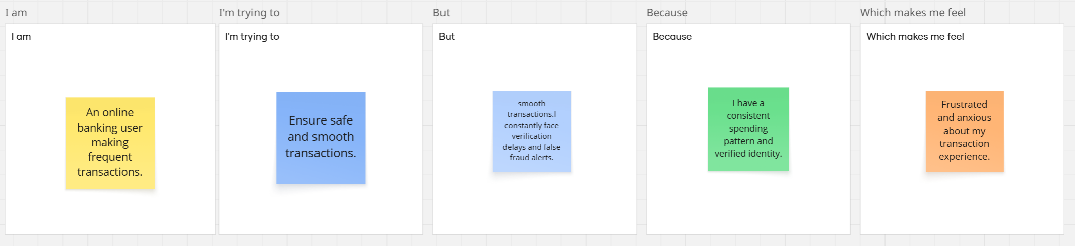

|  |  |  |  |  |  |
| --- | --- | --- | --- | --- | --- |
| Problem Statement (PS) | I am (Customer) | I’m trying to | But | Because | Which makes me feel |
| PS-1 | An online banking user making frequent transactions. | Ensure safe and smooth transactions. | I constantly face verification delays and false fraud alerts. | I have a consistent spending pattern and verified identity. | Frustrated and anxious about my transaction experience. |